
HISENSE EUROPE PR – SDA CORDLESS VACUUM CLEANERS IFA2023 BLOG/PRESS

DO YOU KNOW THE BENEFITS OF CORDLESS VACUUM CLEANER?
No matter how hard we want to avoid it - good old vacuuming job still holds the key to a happy place. However, there are more benefits to it, when we choose a highly efficient, as well as light and eye-catching vacuum cleaner. One that moves cordlessly and leaves your place spotless. Hisense cordless vacuum cleaners are here to give you a perfect example of what is possible in the world of vacuuming. You can think in terms of innovation, high performance, and stylish design. Cyclonic or regular, both are here to do the best job for you.
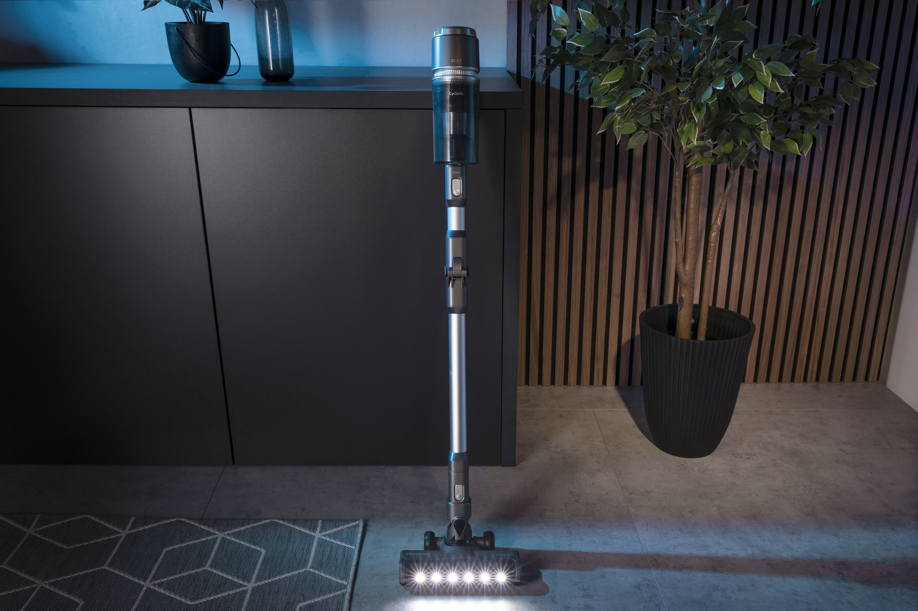
Photo link: http://mabagor.gorenje.cc/?PanelContentURL=/files/Item.asp%3FItemID%3D242147
How to choose your “perfect match”?
In a world full of choices, where you can get lost among all the options to choose from, follow these five steps. Think about ease of use, handling, and maintenance, suction power, and noise level. Once all this is covered, check out the rest of the technical bits, consider your budget and find a nice-looking appliance. Let be honest, it won’t be a love at first site, but as close as it gets with, well, a vacuum cleaner.
When wondering which type of vacuum cleaner could suit you best, consider the whole range of benefits from cordless vacuum cleaners.
Check some specifics
Cordless: particularly suited for getting to places, bigger vacuum cleaners cannot reach. As they are lighter, they are also more portable and easier to use for quick jobs, like picking up something spilled in the kitchen or light cleaning and maintenance. But as they allow greater portability you can even take them to your weekend house to clean there, too.
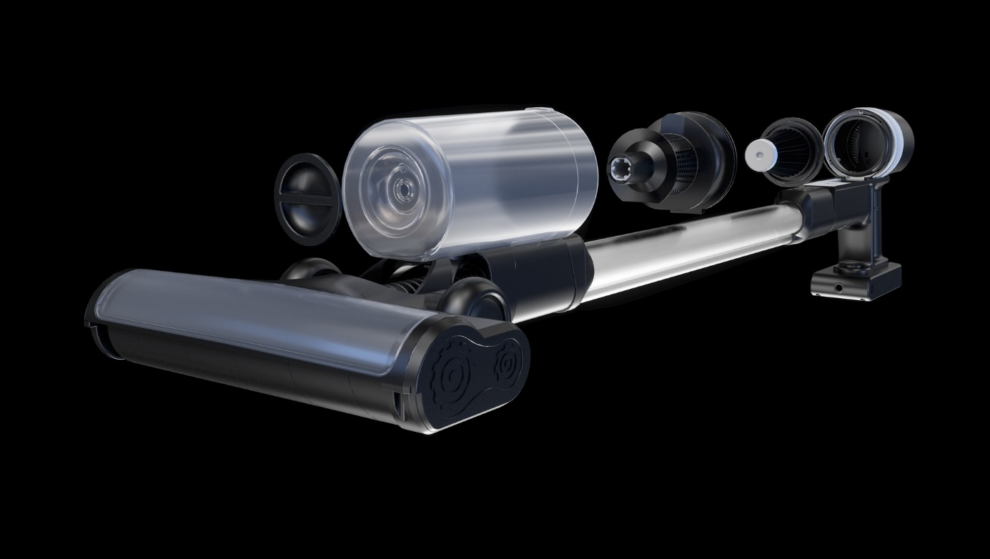
Photo link: http://mabagor.gorenje.cc/?PanelContentURL=/files/Item.asp%3FItemID%3D185014
Suction power: cordless vacuum cleaners have maybe started on the market as convenient for light cleaning of hard floors, but soon some of them became powerful enough to become your main vacuum cleaner at home. Suction power has become truly the motor for doing the good job. Make sure your vacuum cleaner has enough suction power to pick up a variety of messes, including pet hairs.
Inverter technology: if you want to be truly efficient, choose extra powerful appliance that will help your home look neat and clean in effortless way. InverterTech in Hisense cordless vacuum cleaners means longer-lasting, quiet and energy efficient motor. You can rely on less vibrating and extra powerful appliance.
Battery: detachable battery is always a good choice, as you can easily recharge it anywhere in the house. It will not use much space and will soon indispensable. Search for Li-lion technology in battery, that gives it true power. Hisense Hi-Move cordless vacuum cleaner is really the most reliable choice in this manner. It will keep up with 45 minutes of vacuuming, which means you can easily clean the whole space in one go. Lithium-ion batteries have more advantages: they provide more stable suction power; even when at one half of capacity, you will still get top performance; they charge conveniently fast and can hold charge efficiently compared to other types of batteries. Their weight is low, they can be smaller in size, they are rechargeable and the run time after fully charged can be relatively well predicted.
Ability to reach edges and corners: Cordless vacuum cleaners are designed for convenience in cleaning hard-to-reach places, so foldable tube and flexible wand can do their magic in every corner of the room. A good vacuum stick should allow you to vacuum crevices and around objects – whether by use of an attachment or the compact/convertible design of the vacuum. Thanks to a flexible wand, designed to bend in the middle at Hisense Hi-Move IV cordless vacuum cleaner, you can clean easily under low furniture without having to move them.
Brush roll: brush roll is a necessary tool for properly cleaning carpets. With stick vacuum cleaner the brush also ensures that the debris doesn't fly around when cleaning smooth surfaces and hard floors. So, the option of brush roll is a plus when checking the cordless vac. We suggest you check the technologically superb turbo brush with an extra-wide motorized brush-roll ensures better suction at Hisense Hi-Move IV new generation of cordless vacuum cleaners. It picks up dirt and debris across both hard floors and carpets. One-click detachable design allows easy removal of the brush-roll for easy maintenance. Soft linings and bumpers make it kind to your hard floors and furniture.
Ease of maintenance: Simply emptying the dust container is enough to make this vacuum cleaner easy to maintain. Easy opening and gently brushing the filter when emptying container works really handy for everyday jobs.
Versatility: Where there is handiness in cordless stick, you can also enjoy all the advantages of an upright vacuum cleaner that turns into a handheld in mere seconds. From vacuuming the floor to taking care of the sofa, car interior, or hard-to-reach top shelves, 2 in 1 vacuum cleaner certainly hold the ability to please your needs in most beneficial way.
Storage: Some sticks come with wall mounts to save floor space. As a plus, some come with docking station that keep your vacuum cleaner charged, when hanging on a wall. Storage should be easy and convenient, so check out the design of the vac and go for all-in-one to save space and enjoy in elegant and convenient design.
To sum up the best choice out there
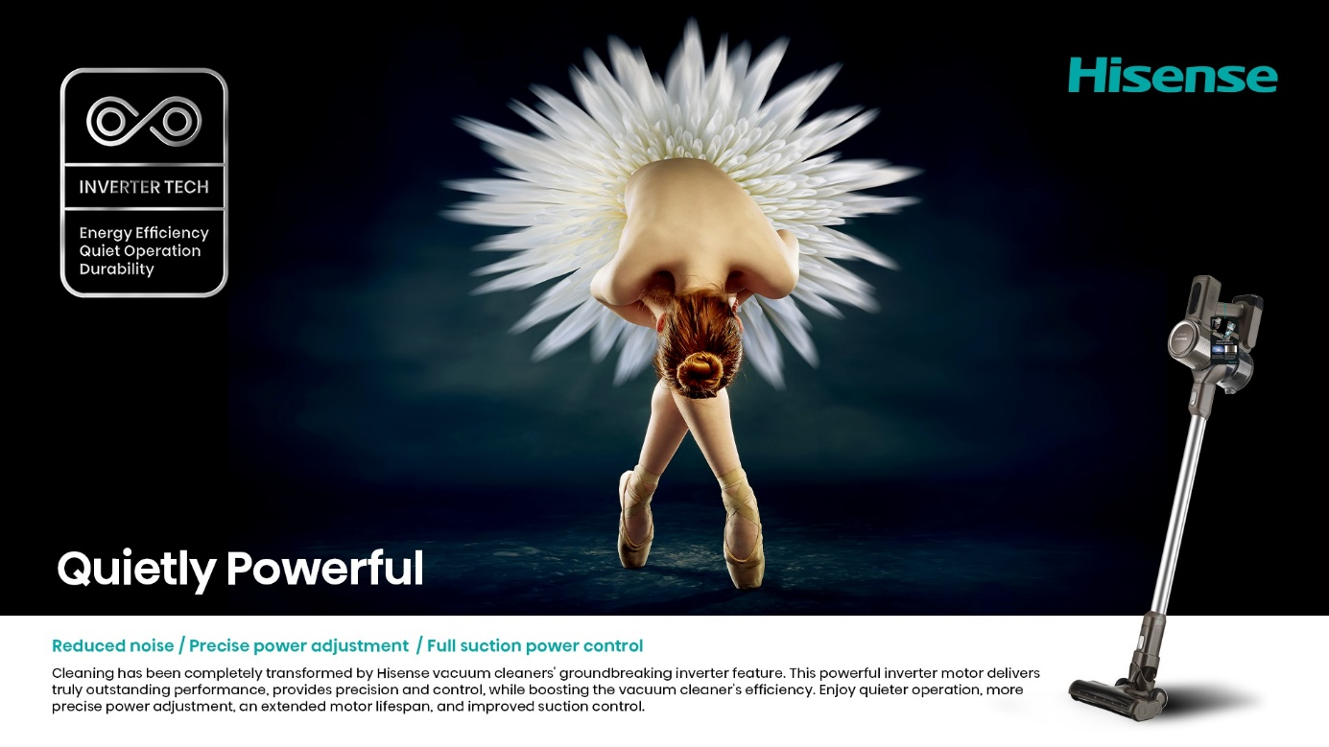
Photo link: http://mabagor.gorenje.cc/?PanelContentURL=/files/Item.asp%3FItemID%3D241395
Cordless Vacuum Cleaners from Hisense are a great alternative to regular vacuum cleaners. They are lightweight and easy to move around. With no cord you will have no limits. They can transform to a handy handheld vacuum cleaner in a matter of seconds and are ideal for quick fixes for which you only have a minute.
Check out our Cordless Vacuum Cleaners Hi-Move IV range results of elegant design skilfully combined with high-tech functions and features for always perfect results.

Video:
https://www.youtube.com/watch?v=bQjfqIXEj6U

