
GORENJE PR – SDA CONTACT GRILL IFA2023 BLOG/PRESS

Summer kitchen: fire up your grill!
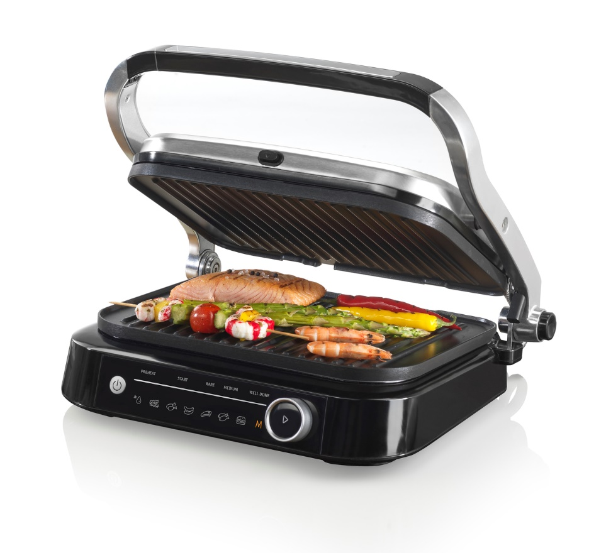
Photo link: http://mabagor.gorenje.cc/?PanelContentURL=/files/Item.asp%3FItemID%3D205203

It’s that time of the year when you can drop everything and throw your mini cooker in the car, head outside with friends, and feast all day in the glorious sunshine. Having the best portable contact grill will make this experience even better! With this you are just one step away from turning the ordinary summer into a grilling feast season.

Gorenje contact grill GCG2100S is equipped with all the necessary grilling skills, so you don’t have to worry about a thing. With non-stick plates, sensors, automatic programmes, and adaptations you can expect always perfect results.

Tasty feeling everywhere

Of course, summer is perfect for parties outdoors, but when the weather doesn't permit, you can always make the inside feel tasty and summerish! Gorenje contact grill is lightweight and small enough to not take too much space, so even if you travel to another location, you can always take it with you.
Imagine the tasty lunches, brunches, or dinners you can enjoy!

Photo: http://mabagor.gorenje.cc/?PanelContentURL=/files/Item.asp%3FItemID%3D197222

Your question – grill's answer

To truly be ready for any occasion that my pop-up in summer and kind of take you by surprise, you should know how to simplify grilling . So, there are some questions you might need an answer to before you start your summer journey.

- Never grilled before? No problem, there are 7 pre-set programmes with automatic adjustment of the temperature and time.
- Can I burn my meat? Never. Auto-Cook automatically adjusts the timing of grilling according to the thickness of the food.
- Must I open the bar to check the food while grilling? No need. The grill does it for you. The smart control panel will show you the progress with lights and sounds.
- What if I forget to turn off the grill? Don’t worry. Once the food is done, the grill automatically shuts off after giving you 3 sound signals.
- Do I have to oil the plates? No need. Non-stick plates use little to no oil to cook, therefore you can easily enjoy a healthier meal.
- Maybe I need a bigger grill surface … No problem. No problem. Contact Grill allows you to grill with lid fully open, which simply enlarges your grilling area.
- Can I use the grill for defrosting? Of course. Pre-set defrosting programme automatically sets the optimum temperature to slowly soften the food.
- Should I pay attention to grease dripping over the grill plate? Never. All the fat from food is collected in a special tray you can easily open and empty, as well as wash and dry quickly.

Unusual recipe for cool summer night

You can make your summer grill more exciting by including a few creative grilling ideas on the menu.
Here is the recipe for bacon wrapped date salad!

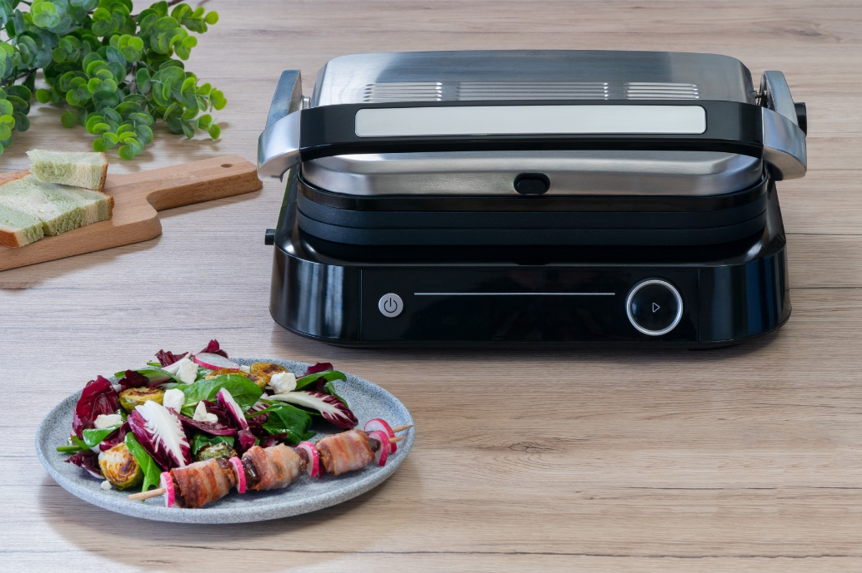
Photo link: http://mabagor.gorenje.cc/?PanelContentURL=/files/Item.asp%3FItemID%3D203649
Ingredients:
• 200 g brussel sprouts
• 200 g radicchio
• 150 g baby spinach
• 80 g radishes
• 3 tbsp olive oil
• 2 tbsp balsamic vinegar
• salt and pepper
• 12 dates, depitted
• 12 slices of smoked bacon
• 100 g feta

Method:
Preheat the oven to 200° C.
2. Halve the brussel sprouts and mix
them with 1 tbsp olive oil and ˝ tsp
salt.
3. Place them on a tray and roast
them for 25 minutes.
4. In a large bowl mix together
radicchio, baby spinach, brussel
sprouts, olive oil and balsamic
vinegar. Season with salt and
pepper by taste.
5. Wrap one slice of smoked bacon
around a date.
6. Turn on the grill and select bacon
programme.
7. When the grill is hot and ready, place
on the wrapped dates and close
the lid.
8. Grill the dates for 30 seconds then
place them on a plate.
9. Top the salad with grilled bacon
wrapped dates.

Enjoy your summer & grill your time out!

