
GORENJE PR – SDA MMC IFA2023 BLOG/PRESS

The baking season is just around the corner – are you ready?

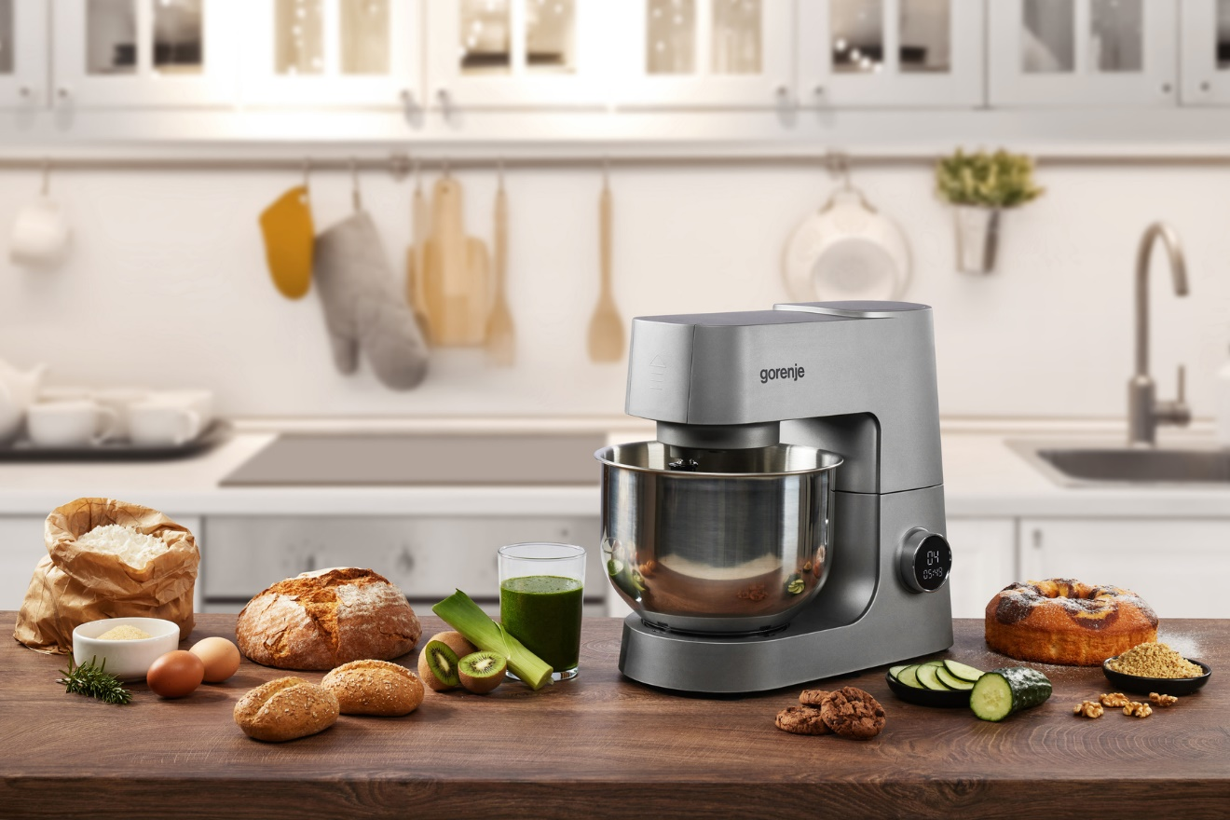

Photo link: http://mabagor.gorenje.cc/?PanelContentURL=/files/Item.asp%3FItemID%3D238850

As the end of the year is approaching in high speed, the mood for baking is becoming more and more present.

We can already imagine the warm home where the smell of freshly baked biscuits is circling around everybody. We can catch a warm festive feeling in the atmosphere and our hearts start beating in the rhythm of joy.

Are you ready to dive into this feeling and let your imagination fly free? Well, we are also aware many have struggles baking. Either you are extremely skilled, or you are just struggling with basics – there needs to be a balance. That sweet aroma of vanilla, chocolate, and all those delicious ingredients makes everyone's mouth water, but the only problem lies in pre and post-baking. However, there is an easy solution to this – the kitchen machine. So, if you want to make your home such a happy place, we can certainly help!

New line of Gorenje kitchen robots is set to become your best friend in the kitchen. If you are a pro or just a beginner in baking, there is no difference. You can use the kitchen machine in any possible way to provide this special season feeling in your home.

More than just baking

Planetary mixing, attachments for kneading dough, for mixing and highly efficient whisk, 12 speeds and pulse function, automatic rpm regulation for the desired mixture, 6 l stainless-steel mixing bowl volume, transparent anti-splash lid and soft start motor will help you to fully enjoy the kitchen time! Plus, you will get the perfect results with it. When going for those little extra parts like 1.5 l glass jug blender– you will definitely make your kitchen a joyful place to be. You can prepare a versatile food only in one machine and keep your kitchen counter clean and clear.

Gorenje's multifunctional mixers are definitely designed for more than baking. They'll unlock your cooking potential and culinary possibilities. See how you can use them to their full capacity and get ready to match your creativity and style with direct experience. Check out how they work!

A few tips for better kitchen machine experience

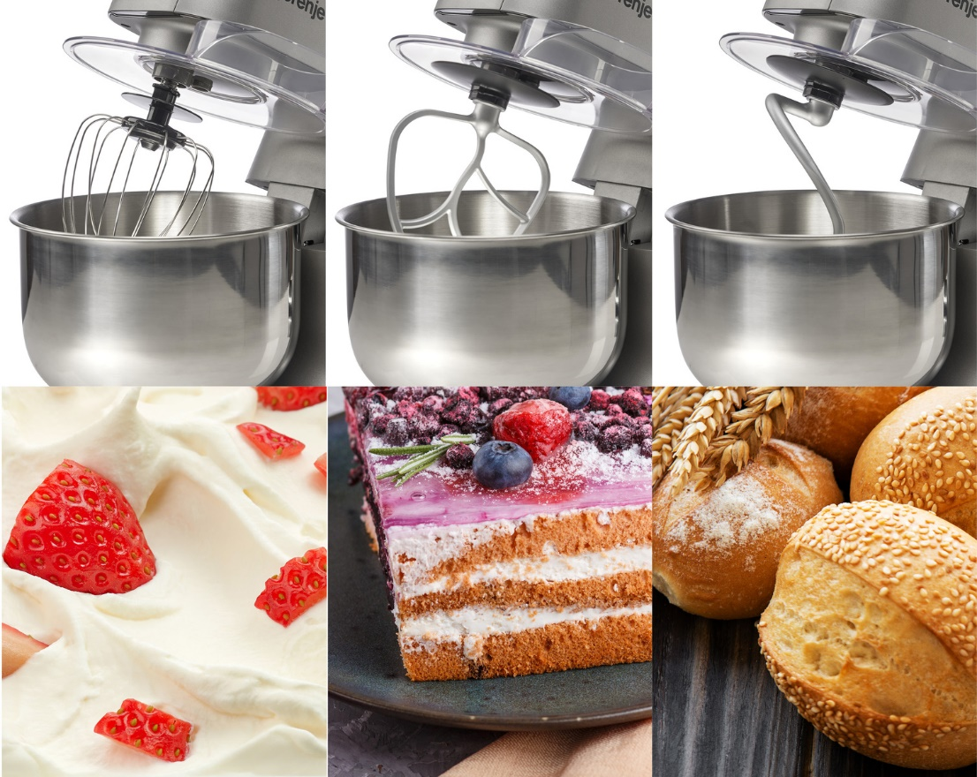

Photo Link: http://mabagor.gorenje.cc/?PanelContentURL=/files/Item.asp%3FItemID%3D239105

- Don’t skip user manual
Don’t use your kitchen machine without going through how to use video and/or reading the instruction manual. It will tell you how many pounds of flour your kitchen machine can handle at once and it will for sure help you decide whether or not to double up on recipes.

- Starting off on hjgh speed
Always start mixing on low, then ramp up to high speed. In this way you will avoid spattering all around.

- Chill the bowl and beater
If the bowl and beater are cold, they’ll help you whip up the loftiest, fluffiest whipped cream.

- Take the beaters for a spin
When finished mixing, raise the beaters slightly above the surface of the food. Then, run the mixer starting on a low, then high, to spin off any excess mixture. You’ll have easier job cleaning the appliance.

