
SENSE EUROPE PR TOOLBOX – IFA 2023 SDA PRESS RELEASE

Premium features at Hisense Microwave ovens

Hisense microwave ovens will enrich your kitchen with new lines of contemporary living and your cooking experience with new flavours of surprise. Cutting-edge technology and high-quality materials enable combined operation of microwaves, convection, and grill and thus allow you to bring out the most desirable flavours and aromas from each dish. You will find Hisense models truly energy-efficient, especially models with Inverter technology that will deliver a constant stream of power leading to faster cooking time and more evenly cooked food.

Spice up your daily nutrition with countless options of fast and efficient food preparation, employing the pre-set cooking and roasting programs. Hisense microwaves with a modern appearance will immediately blend in with your kitchen and their new advantageous benefits will make your life better.

We want to emphasize the high-quality of Hisense Microwaves with premium features that will bring you a high-quality cooking experience.

INVERTERTECH
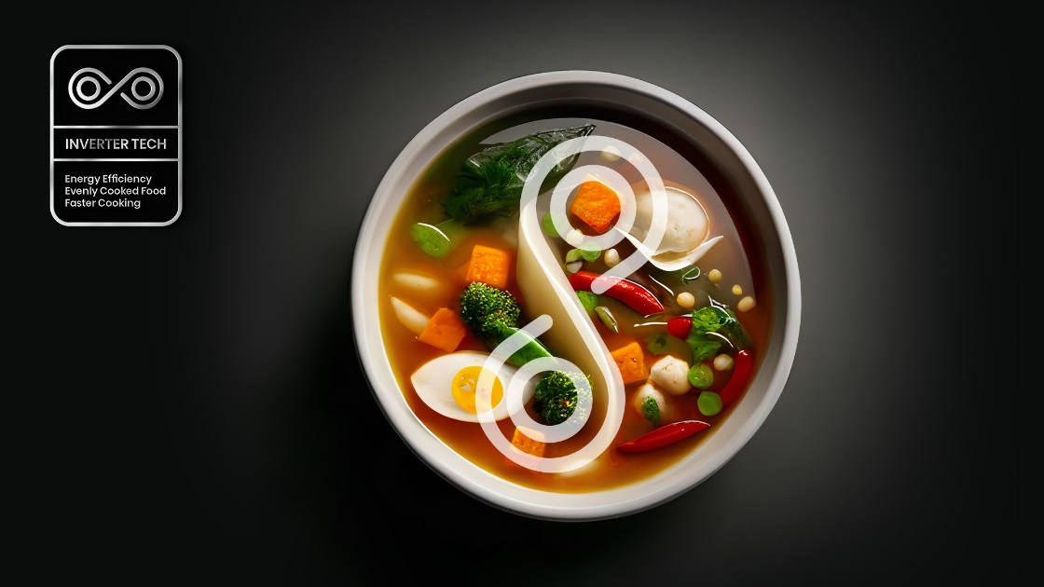
Photo: http://mabagor.gorenje.cc/?PanelContentURL=/files/Item.asp%3FItemID%3D241391

The state-of-the-art Hisense inverter motor delivers constant, precise and energy-efficient cooking performance. It ensures evenly and perfectly cooked dishes, with more flavour, shorter cooking time and noticeable energy savings. Switch to Hisense inverter technology and enjoy superior cooking precision and delicious gastronomic results.

Key User Benefits:
- Energy efficiency
- Evenly cooked food
- Faster cooking

PREMIUM GLASS

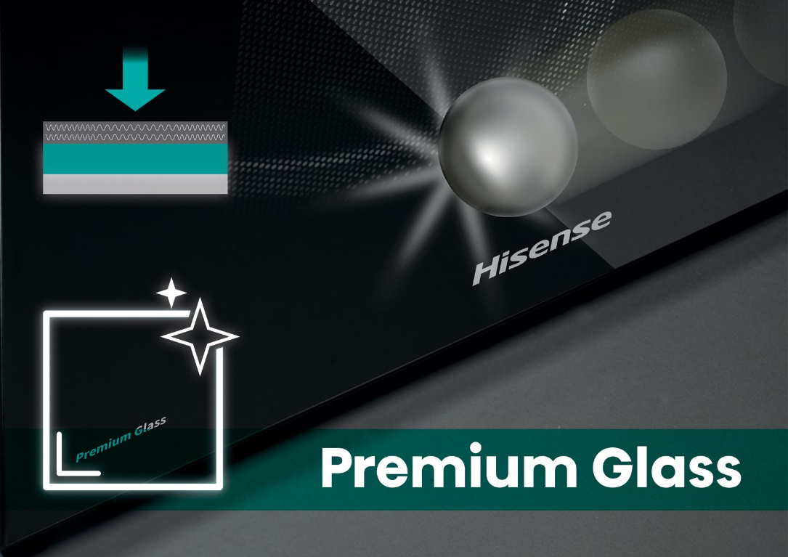
Photo: http://mabagor.gorenje.cc/?PanelContentURL=/files/Item.asp%3FItemID%3D227644

Premium Glass is approximately 4 to 5 times stronger and safer than untreated glass. It puts the safety on the first place. It is resistant to heat and sudden temperature changes as well as to scratches. Full premium tempered glass door enhances stylish look of your kitchen, giving it neat and premium feel. Smooth and minimalistic appearance blends beautifully into every kitchen.

Key User Benefits:
- Safe and reliable
- Resistant to heat & scratches
- Easy to clean & maintain
- Premium look & feel

CERAMIC COATED CAVITY
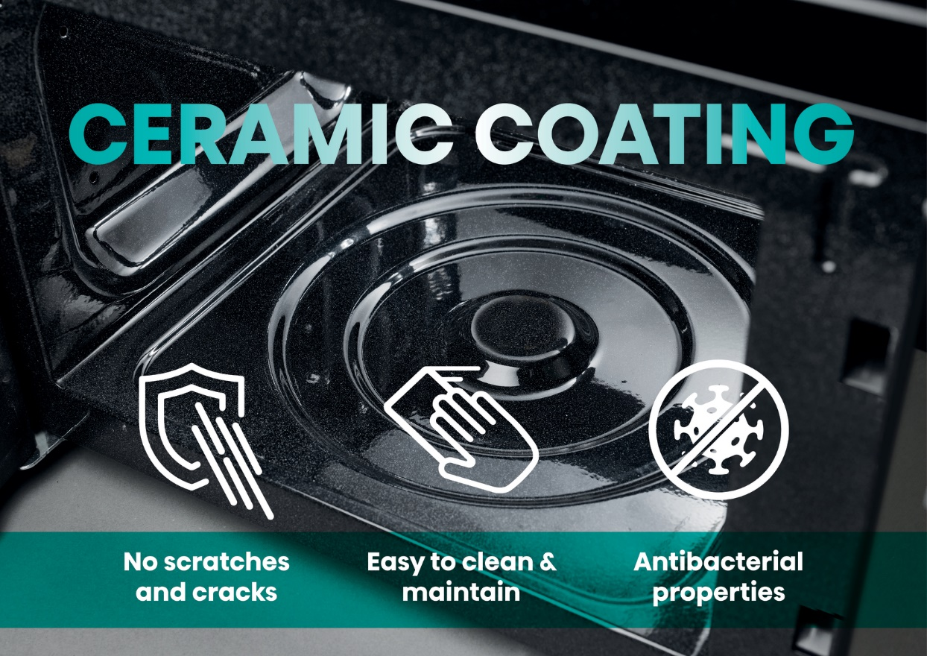
Photo: http://mabagor.gorenje.cc/?PanelContentURL=/files/Item.asp%3FItemID%3D227641

Ceramic coated cavity means solid high-end finish. The interior of Hisense microwaves is fully coated with ceramic, which has a large set of advantages. It offers a solid surface which is extremely scratches and cracks resistant. Any food residues don’t stick to the walls and are easy to clean. Just a quick wipe with a damp cloth after use is all you need. Ceramic finish also has antibacterial properties, that prevent any bacterial attack. Premium coating gives a product high-end look and feel.

Key User Benefits:
- No scratches and cracks
- Easy to clean & maintain
- Antibacterial properties

With the new generation a Hisense microwave oven has become an indispensable part of every kitchen. Enjoy and take a full advantage of your new Hisense appliance.

