
HISENSE EUROPE PR TOOLBOX – SDA IFA2023 ROBOT VACUUM CLEANERS PR ARTICLE

New robotic vacuum cleaners for carefree and optimal cleaning
HISENSE Robot Vacuum cleaners on the go
A smart and elegant vacuum cleaner with special mop technology addition will help you get your hands off annoying tasks at home such as cleaning floor and making your space spotless. Once set up, it will do almost all the work of cleaning, which can give you more time to do the things you love. If you haven't considered buying a robotic vacuum cleaner yet, here you might find some reasons to buy it, after all.
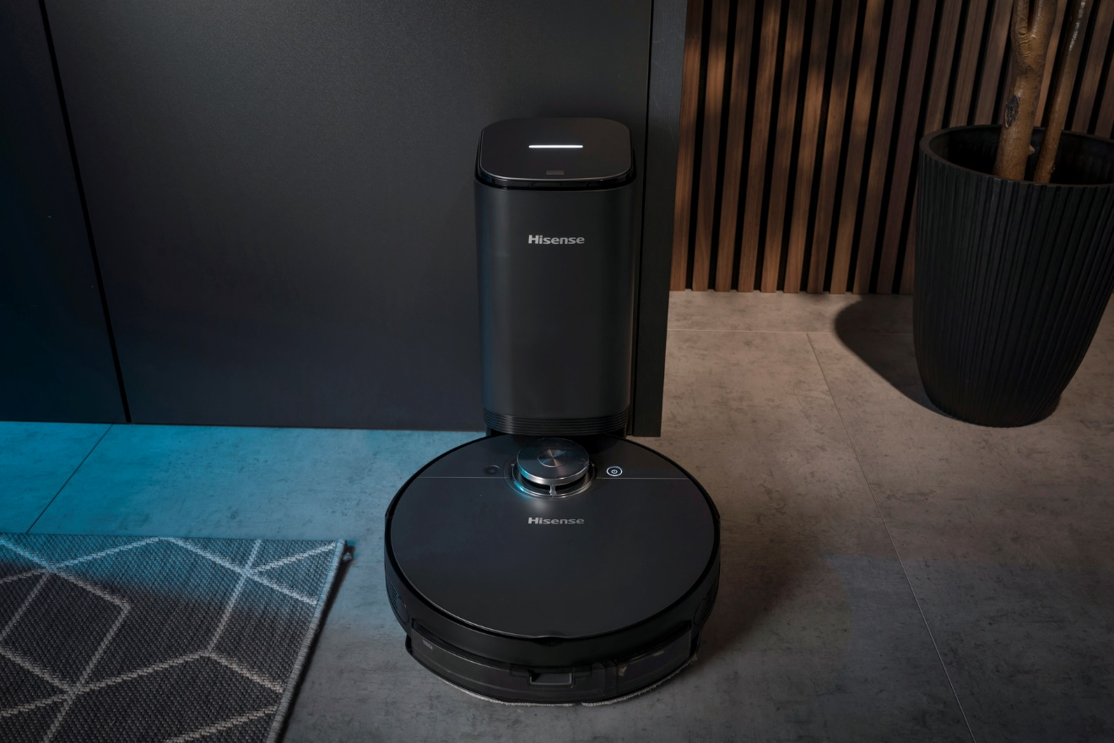
Photo: http://mabagor.gorenje.cc/?PanelContentURL=/files/Item.asp%3FItemID%3D242145
Forget moving the furniture before vacuuming. Thanks to their compact size and height, Hisense robotic vacuum cleaners can effectively and automatically clean under the sofas, beds and other larger furniture and reach even the tough-to-reach spots. Their ability to sense the changes in the surface underneath and adjust accordingly eases the vacuuming of hardwood or carpet. No matter what the surface, they can handle the cleaning task perfectly.
Trusting your AI helper can be tricky, but 30 sets of highly sensitive sensors, including
anti-collision, anti-fall and closed area will provide best user experience and enable you to trust your robot. It will know your home even better than you.

You can control the robot much easier using the mobile application as a remote-control device. If you are not at home, the appliance can still do all the work as required. Simply apply Connect Life mobile application on your smart phone and command your AI house assistant to start its job. The application is available in Google play and App store. This allows programming everything using your smart phone: from creating a cleaning schedule for different rooms, enabling spotted cleaning mode, to building virtual walls for no-go-zones, which all should be easily accessed from your pocket. Smart technology 360° laser eye for models RVCL144AB and RVCLS144AB enables robotic vacuum cleaner even to map its surroundings to effectively clean the rooms. Visual simultaneous localization and mapping (VSLAM) algorithm calculates the optimal cleaning route and includes breakpoint memory function. It also creates a stored map, so you have a full control where the vacuum cleaner goes. Robotic vacuum cleaner works perfectly also at dark.
With laser eye technology the higher-ranking models will use 2-step intelligent cleaning. At first step, the360°laser eye will scan the layouts to understand the layout of furniture and then to map out the real-time interiors of your house. At second step these robots will map the space and thus path planning before starting to clean. You can also switch from selective room or area cleaning, one by one cleaning, deep cleaning, zig zag cleaning and thus, reach every corner of your home in the most effective way.
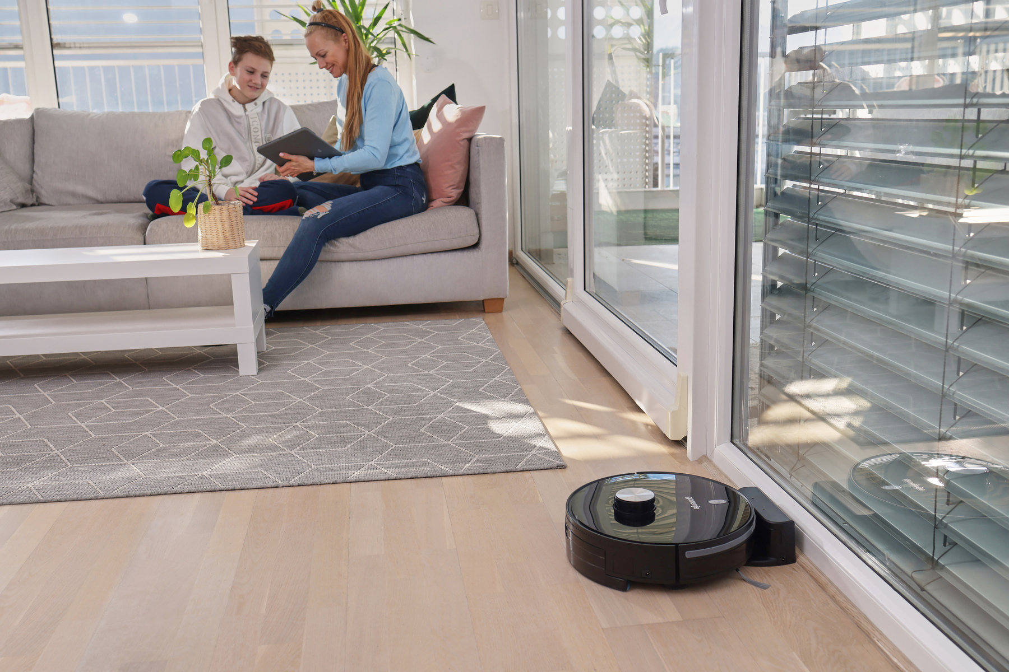
Photo: http://mabagor.gorenje.cc/?PanelContentURL=/files/Item.asp%3FItemID%3D231596
Extra powerful 4000Pa BLDC motor brings excellent cleaning experience to your home. It offers you 3 levels of suction power to choose from. Seeds, beans, powder, or rice grains are easy to be cleaned. The life span of the motor is also quite remarkable!
These 2-in-1 models also offer a mop function, which is usually even less pleasant chore than the vacuuming itself. So, using a mop attachment is convenient to vacuuming and mopping all the hard floors (like tiles, parquet, laminate) at once. This is a big time-saver when there are children and pets around. And what is more satisfying than freshen up your floors with only with a touch of water?
More advanced model (RVCLS144AB) will perform even better than you expect. Vibrational mop technology is stimulating actual "scrubbing" movements, which will help effectively clean the floor. Split soft mop will bring better effectiveness in wiping the floor and, we are sure; you will feel very much content with it. The e-controlled water tank and three water flow speeds are adding to your great user experience and will suit any need you have.

With the ability to empty its own dustbin, RVCLS144AB is one of the more self-sufficient robot vacuum cleaners. The intelligent dust bin collector station automatically empties the robot's dustbin after every job done, so vacuuming more than once and have the cleaner always ready is another good reason to have such a helper at home.
Another great reason to have such a helper at home is in no need to take care of charging you robot when it comes to low battery. Every time the robot finishes cleaning, it would automatically return to the dock station to recharge and get fully ready for your next cleaning! Once the 5200mAH big batteries are full, the robotic vacuum cleaners will resume cleaning until the work is done. Fully charged, it ensures 150 min running time, covering 250m² area while powerful BLDC motor enables silent operation.

Here is also another big reason to have one at home. Robotic vacuum cleaners are economical and cost-efficient. Not to mention they are much cheaper than expensive housekeepers. The machine can be set to clean exactly as required, while requiring little maintenance. So, your only job is to replace the bag or empty the container from time to time.

Choose the one most suitable for your needs and enjoy cleaning your home with Hisense robot vacuum cleaners!

***

Videos:
RVCL144AB: https://youtu.be/PZ9sm19TP64
RVCLS144AB: https://youtu.be/U2c3o7JVtyY
ConnectLife_robot App video: https://www.youtube.com/watch?v=H6_LhFRXrBw
Hisense Inspire: https://www.youtube.com/watch?v=5EyTKUX6ESM

