
HISENSE EUROPE PR TOOLBOX - SDA PRESS RELEASE

Not Just an Oven. It´s your home fortress.
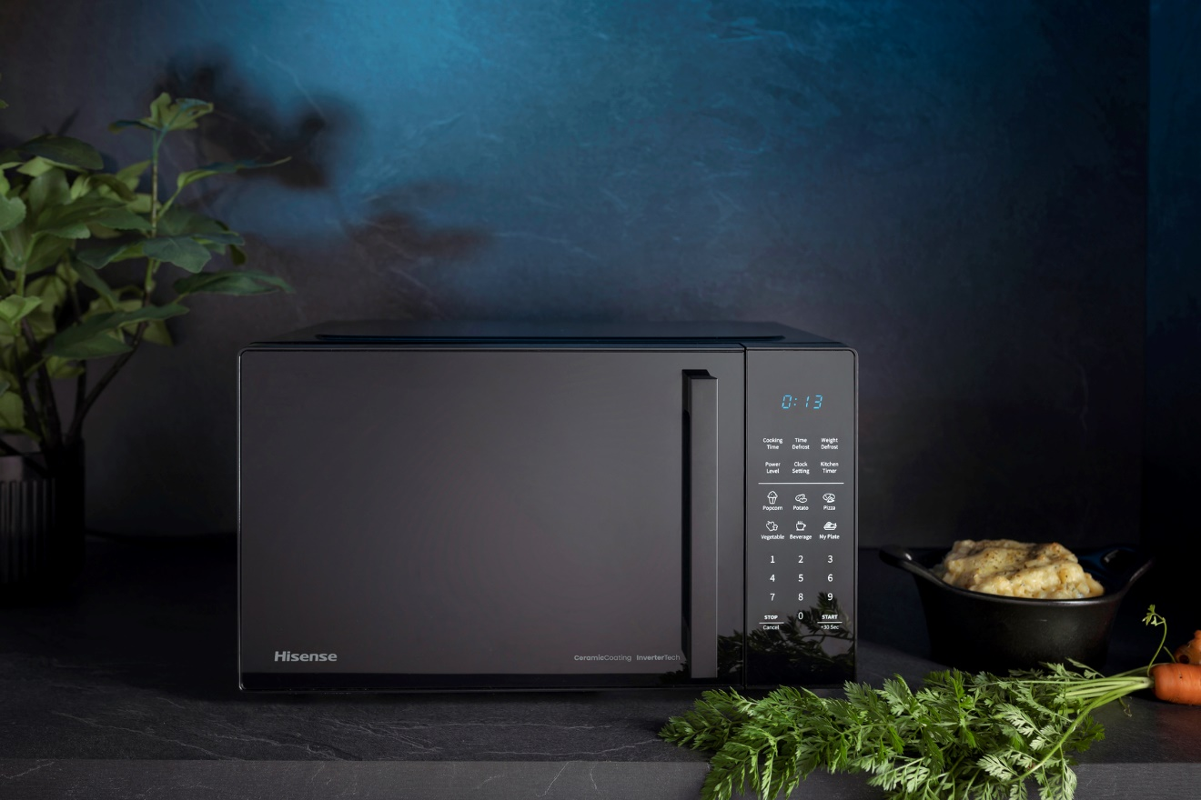
Photo: http://mabagor.gorenje.cc/?PanelContentURL=/files/Item.asp%3FItemID%3D242143
Hisense microwave ovens will enrich your kitchen with new lines of contemporary living and your cooking experience with new flavours of surprise. Cutting-edge technology and high-quality materials enable combined operation of microwaves, convection, and grill and thus allow you to bring out the most desirable flavours and aromas from each dish. Spice up your daily nutrition with countless options of fast and efficient food preparation, employing the pre-set cooking and roasting programs. Hisense microwaves with a modern appearance will immediately blend in with your kitchen and their new advantageous benefits will make your life better.

There are more types of users regarding Hisense MW:
  - LIGHT USER enjoys HISENSE microwave primarily for melting and reheating or perhaps making popcorn. You won't need lots of fancy features, so choose any from our range.
  - FANCY USER enjoys experimenting with products and recipes. He will use microwave to prepare entire meals - even spaghetti or meatloaf. Premium HISENSE microwaves are here if you are looking for the latest innovations and more variable features.
  - FAMILY USER is using the HISENSE microwave together with young children or older persons. Bigger volume, simplicity, ease of use, ease of cleaning and safety features are a must.

All microwaves from the Hisense Basic Range are mechanical and are bringing you benefits you need for the easy and comfortable use:
- Tailor your cooking experience by choosing the right power level. High power is great if you want to heat something as quickly as possible if you are boiling water or cooking non-creamy soups. Medium settings allow you to steam or fry foods, while low settings are suitable for cooking creamy soups and can also act as dehydrator.
- The fastest use of microwave is just to set the operating time. The timer is clearly displayed and indicates the time remaining until the end of the cooking process. You can easily do something else, knowing your food will be ready when you are ready.
- You can choose between grill only or three combinations of combined cooking with microwaves and grill. Choose grill only for golden crust dishes or combinations which allow you to roast meat, bake pizza, make soufflés, or cook lasagne much faster.
- To keep the food in perfect condition after defrosting, it is important to thaw it quickly and efficiently. With defrost function the heat reaches the food evenly and simultaneously, with no need to manually lower the power. A microwave oven defrosts by using intervals of low heat.
- 360˚ rotating plate with constant rotation enables the microwaves to heat the food you are preparing efficiently and evenly. Turntable is also key to optimal defrosting.

Microwave ovens from Hisense Premium Range will pamper you even more.
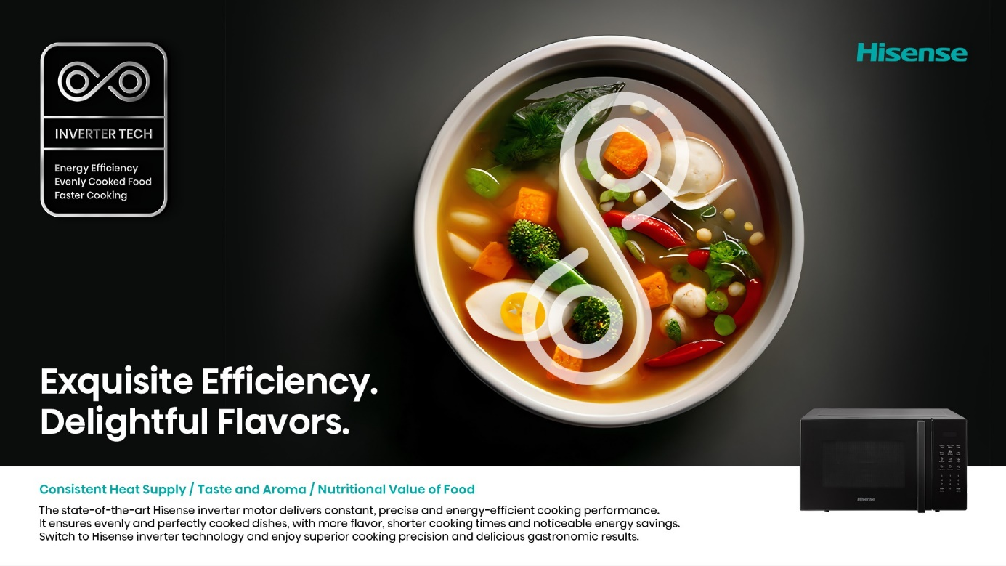
Photo: http://mabagor.gorenje.cc/?PanelContentURL=/files/Item.asp%3FItemID%3D241392

- New models come with state-of-art microwave inverter technology that will redefine the way you prepare food. With MWO InverterTech in your kitchen, you can achieve the ideal blend of energy efficiency, accuracy, and flavour.
- Several models come with (auto)menus featuring pre-set recipes that guarantee perfect results every time. You select the type of food you want to prepare, enter its weight, and the oven automatically chooses the ideal programme and time.
- If you have your favourite recipe and can store it to the appliance (memory function), this will easy your cooking procedure immensely. Maybe saving one recipe for three family members can be even more helpful!
- With the help of the Quick Start function cooking will start immediately at 100% microwave power for 30 seconds. You can always add additional 30 seconds each time you use this function.
- Clearly laid out touch control panel ensure that delicious results are on the tips of your fingerprints.
- A smart LED display is always showing you where you are in the cooking process.
- You can cook in two stages by manually programming steps of the cooking process. For example, in step 1 you may opt for more microwaves than grill, in step 2 choose just grilling to achieve a final crust. When you activate the StepBake mode, the microwave oven automatically follows the steps, so you don´t have to do it manually.
All models are made of the best materials that are simple to clean and maintain. Ceramic coated cavity offers a solid surface which is extremely scratches and cracks resistant. Any food residues don’t stick to the walls and are easy to clean. Ceramic finish also has antibacterial properties, that prevent any bacterial attack. Premium glass is approximately 4 to 5 times stronger and safer than untreated glass. It is resistant to heat and sudden temperature changes as well as to scratches. Full premium tempered glass door enhances stylish look of your kitchen, giving it neat and premium feel.
The oven cavity can be cleaned using the unique automatic cleaning function AquaClean. The moisture will soften the dirt on the oven cavity walls and all that is left for the user is to simply wipe it off with a soft cloth. Oven door is free from any grooves or edges and the front glass panel is made of real tempered glass. Thus, the door can be kept spotlessly clean by simple wiping.
It has been proven that food treated with microwaves retain their natural characteristics well, particularly minerals and proteins. Due to short cooking times, the fats do not change their properties (unless combined cooking with microwaves and infrared rays or grill is selected, which gives the food a tasty crust rich in polyunsaturated fatty acids). Therefore, the food prepared this way can be included in weight-loss or cholesterol-control diets. Vegetable fibres remain unchanged while also retaining the heat-sensitive vitamins (particularly A and C) which otherwise decompose after prolonged cooking or roasting.

With the new generation a Hisense microwave oven has become an indispensable part of every kitchen. Enjoy and take a full advantage of your new Hisense appliance.

