
HISENSE EUROPE PR TOOLBOX – SDA AIR FRYERS IFA2023 PRESS RELEASE

Hisense cares about your health.
Air fryers are among the newest and most popular types of countertop appliances. They cook using circulation of hot air around food. This gives a crispy, crunchy coating without the need to deep fry or use oil. Does an air fryer deserve a spot on your kitchen counter?
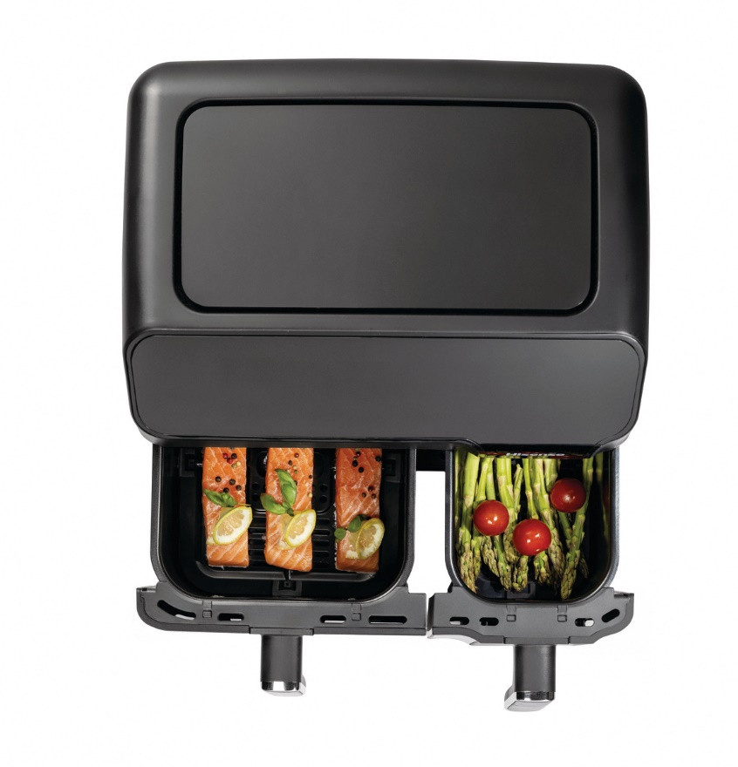
Photo: http://mabagor.gorenje.cc/?PanelContentURL=/files/Item.asp%3FItemID%3D210074

Even if you are usually opting for healthier cooking methods such as baking, roasting, steaming, or sautéing you can´t deny that sometimes the crunchiness and crispiness of fried food is the one you are craving for. Perfect crispiness without fear of too much fat or bad conscience about consumed calories is now possible with the use of air fryer. Beside frying, this versatile kitchen helper can also be used for baking sweet desserts like cookies, muffins, brownies, cake or even for roasting different nuts.
Air fryers cook using convection heating: circulating hot air around food. It´s like using the fan-assisted settings on your oven, but in more compact form. Look at air fried food and you´ll see evidence of the Maillard reaction at work. That´s the chemical effect produced between amino acids and reducing sugars that browns food and gives it a distinctive taste. In other words, an air fryer will provide the taste and texture of fried or roasted food, without you having to immerse your dinner in oil.
Other major benefit of air fryer is that no preheating is needed. This means a significant savings in money and time. Air fryers use far less energy than ovens. Some reports are quoting that with air fryer you use 50% less energy compared to baking in a regular oven.
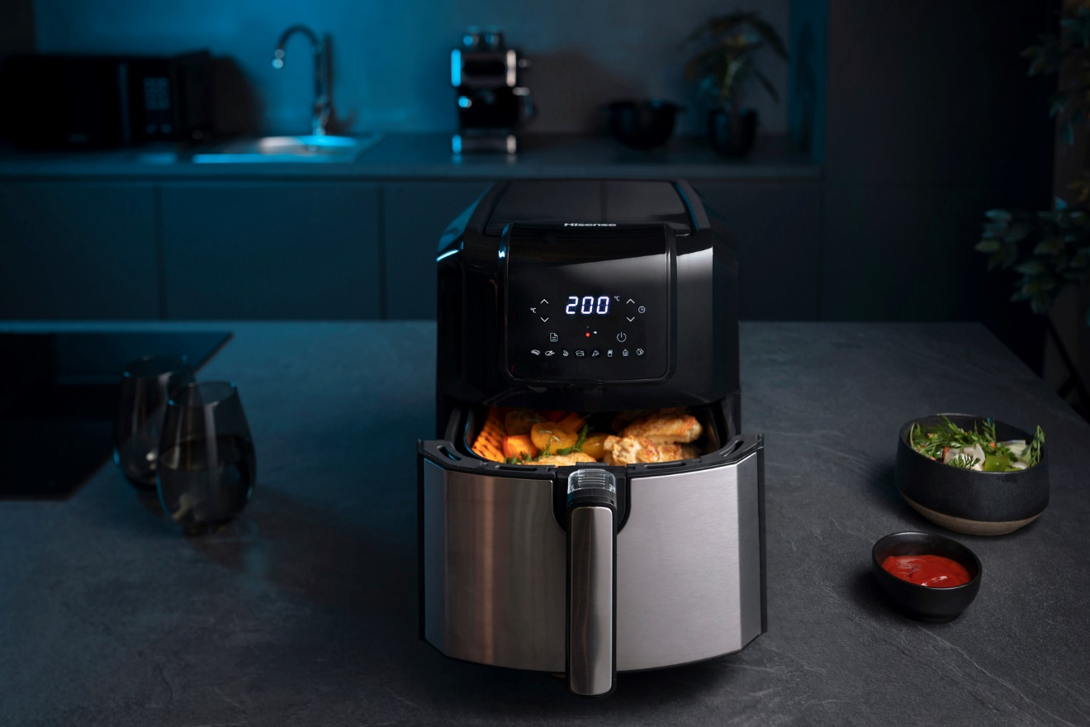
Photo: http://mabagor.gorenje.cc/?PanelContentURL=/files/Item.asp%3FItemID%3D242139

Both Hisense Air Fryer models H06AFBS1S3 and HAF2900D boosts with features that are bringing you the benefits of easy and comfortable use:
- 8 preset programms including French fries, cake, steak, drumsticks, chicken wings, shrimps, roast sausage, or egg tart.
- Manual settings of time and temperature enable you to tailor your cooking experience by choosing the temperature in the range from 80℃ to 200℃ and setting the timer to up to 60 minutes.
- Over LED display with touch control panel, you can easily monitor the cooking process.
- Elevated and perforated fry trays inside each non-stick coated frying basket enable advanced air flow which guarantee crisp results.
Both Hisense Air Fryer models are made of the best materials that are simple to clean and maintain. The frying baskets and crisp trays have a non-stick coating which ensure efficient cleaning. Wipe the baskets with soft cloth after each use to get the best smelling and delicious food every time. The smell of fried food won´t linger around your home as it does when use deep fryer or frying pan.
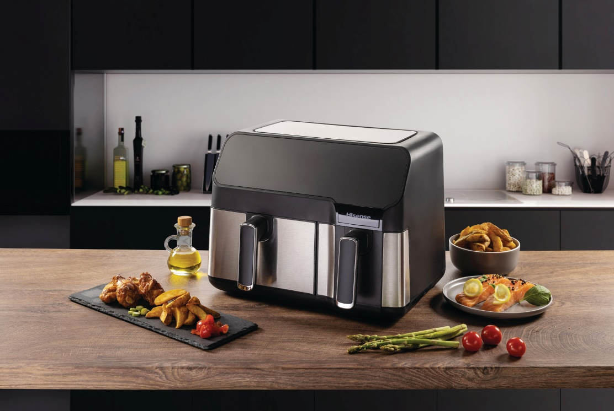
Photo: http://mabagor.gorenje.cc/?PanelContentURL=/files/Item.asp%3FItemID%3D210081
Most of meat dishes, including fish, can be prepared in an air fryer. You can also prepare side dishes, potatoes and vegetables, or experiment with homemade crisps, toasted seeds, and nuts. Because of such endless possibilities Hisense Air Fryer H06AFBS1S3 is now upgraded with HAF2900D - the one that has two independent frying baskets, each with its own rapid heater and cyclonic fan. This lets you cook two foods in two different ways. With the total frying capacity of 8.6 L, you can prepare the complete family meal.
To wrap it up - Hisense air fryer deserves a spot on your kitchen counter, because will save you money (oil & energy) and time while also providing you with delicious and versatile food!

Hisense is a global high technology & quality brand producing home appliances and consumer electronics. Since 1969 we have been pushing boundaries of innovation, working tirelessly on developing cutting edge technology for our customer´s home. It is our aim to make the latest technologies accessible to everyone through thoughtfully designed and expertly built products. Everything we create is designed with the customer in mind. For 5 decades we have been committed to developing innovations in consumer electronics, owning many brands including Hisense, Toshiba, Gorenje, ASKO, UPO, Kelon and Ronshen. Today, we are the No.1 TV brand in China, Australia & South Africa, and the No.2 refrigeration brand in China, employing over 80,000 people across 54 companies as well as boasting 12 research & development centres worldwide. All of which have the sole aim of delivering high quality, cutting-edge and affordable products that improve the life of our consumers. As the Official Partner to the 2020 UEFA European Football Championship™ and FIFA World Cup Qatar 2022™, Hisense is proud to support the biggest and most prestigious sporting events in the world. Hisense are also proud sponsor of one of the world´s best football teams; Paris Saint-Germain.

