
HSENSE EUROPE PR TOOLBOX – IFA 2023 SDA PRESS RELEASE

New video recipes for Hisense Air Fryer

We have just released 5 new recipes, made for Hisense Air fryer. They combine different and versatile ingredients with simplicity of food preparation, resulting in five great dishes. It inspiring to see the capacity of cool air fryers HAF2900D and H06AFBS1S3! All recipes are ready to be shared through your social media platforms.

You will find deliciousness in:
- Bacon wrapped potato wedges
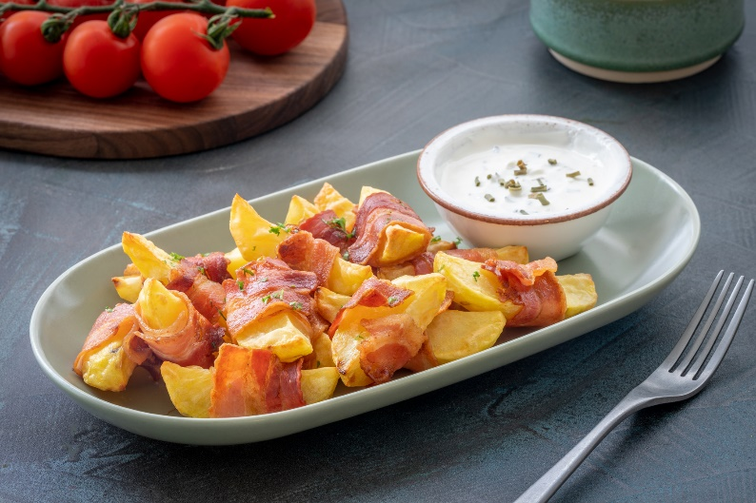
YT: https://youtu.be/ocFAi1RphQ0
Photolink: http://mabagor.gorenje.cc/?PanelContentURL=/files/Item.asp%3FItemID%3D226319

- Buffalo cauliflower with chickpeas
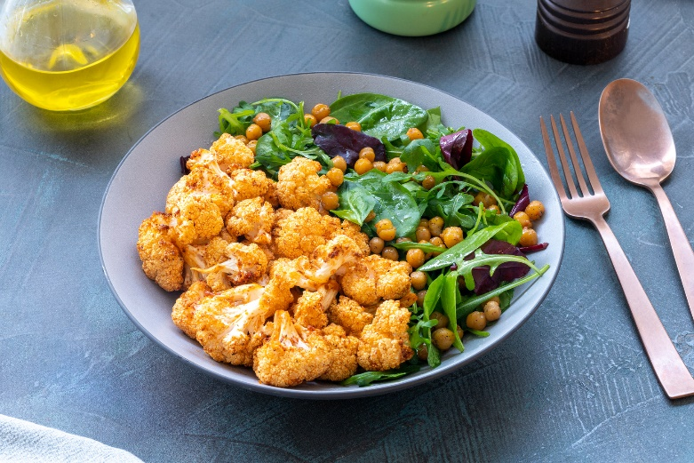
YT: https://youtu.be/VoqJhgfwzlY
Photo: http://mabagor.gorenje.cc/?PanelContentURL=/files/Item.asp%3FItemID%3D226324

- Coconut shrimp with sweet potato
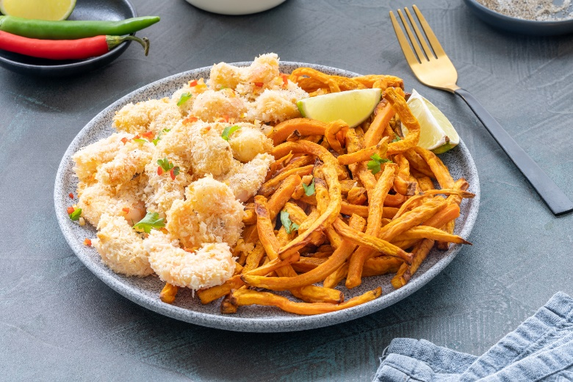
YT: https://youtu.be/5u4ZC4pgPuU
Photo: http://mabagor.gorenje.cc/?PanelContentURL=/files/Item.asp%3FItemID%3D226320

- Roasted brussels sprouts
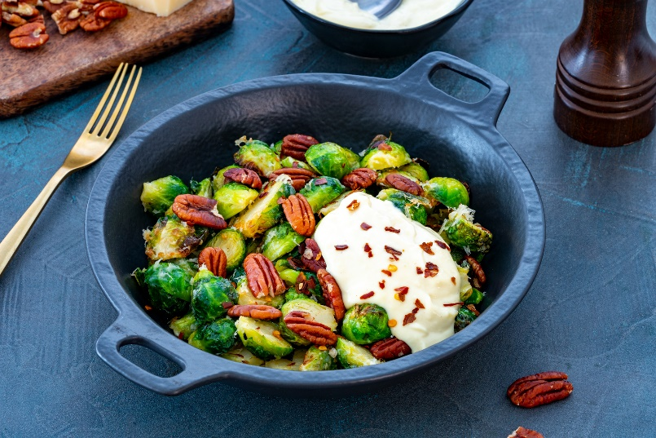
YT: https://youtu.be/pkR71HiOH-o
Photo: http://mabagor.gorenje.cc/?PanelContentURL=/files/Item.asp%3FItemID%3D226323

- Sesame crusted salmon
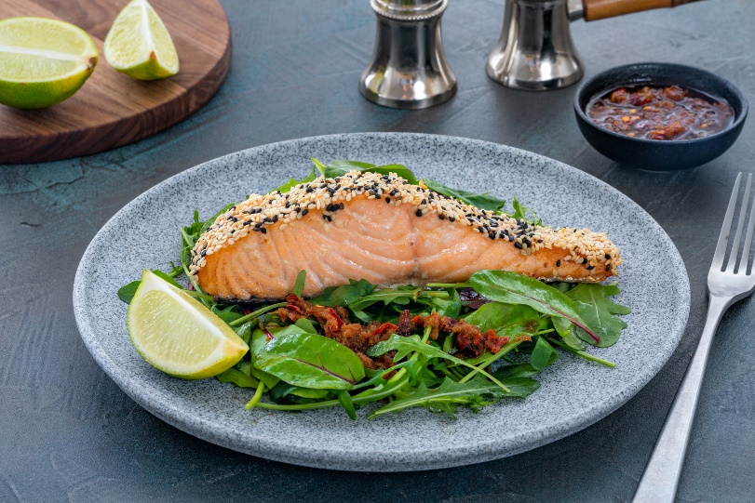
YT: https://youtu.be/69sZi6LFfbE
Photo: http://mabagor.gorenje.cc/?PanelContentURL=/files/Item.asp%3FItemID%3D226327

- Steak fajita with colourful vegetables
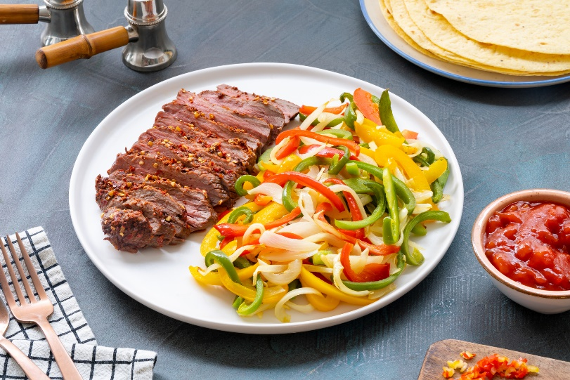
YT: https://youtu.be/0FES-6JhlVM
Photo: http://mabagor.gorenje.cc/?PanelContentURL=/files/Item.asp%3FItemID%3D226328

Enjoy!

