
GORENJE PR – SDA IFA2023 PRESS MOMENTS OF RETRO CHARM

Gorenje RETRO line of small domestic appliances
Moments of Retro charm

At the IFA 2023 fair, Gorenje is presenting the extended Gorenje Retro collection of small domestic appliances. The unique design collection represents a new take on ‘good old days’ concept and it promotes the stylish addition to your Retro kitchen. Along with technological advancements and intuitive user experience the highlight goes on the elegant retro simplicity. With the awe-worthy kitchen helpers, such as the kettle, toaster, blender, hand blender, kitchen machine and microwave oven, you can relieve the carefree moments of retro charm.
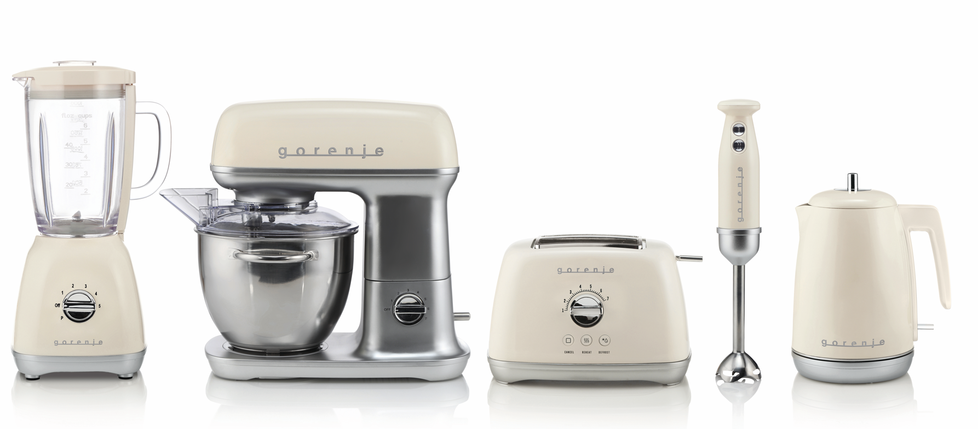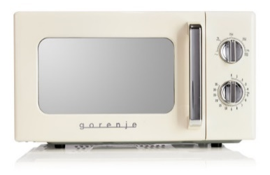

Every now and then we find ourselves longing for the good old days. When life was simpler, the weather was nicer, and times were slower. With the Gorenje Retro Collection you can relive those carefree moments, but now vintage design comes with some passion and refreshing advanced technology.
The new collection of small domestic appliances with 100% matching design compliments the range of major domestic appliances and simplifies the cooking process. The range includes sophisticated, yet practical, powerful, easy-to-use and easy-to-clean blender, hand blender, kettle, toaster, available in vintage ivory and black, and kitchen machine in ivory as well as in black, apple, olive and copper colour, all with metal accents and ergonomic design for a better, more comfortable grip and handling.
It’s all about the passion. A passion for design and passion for cooking. And with Retro collection you have it all.

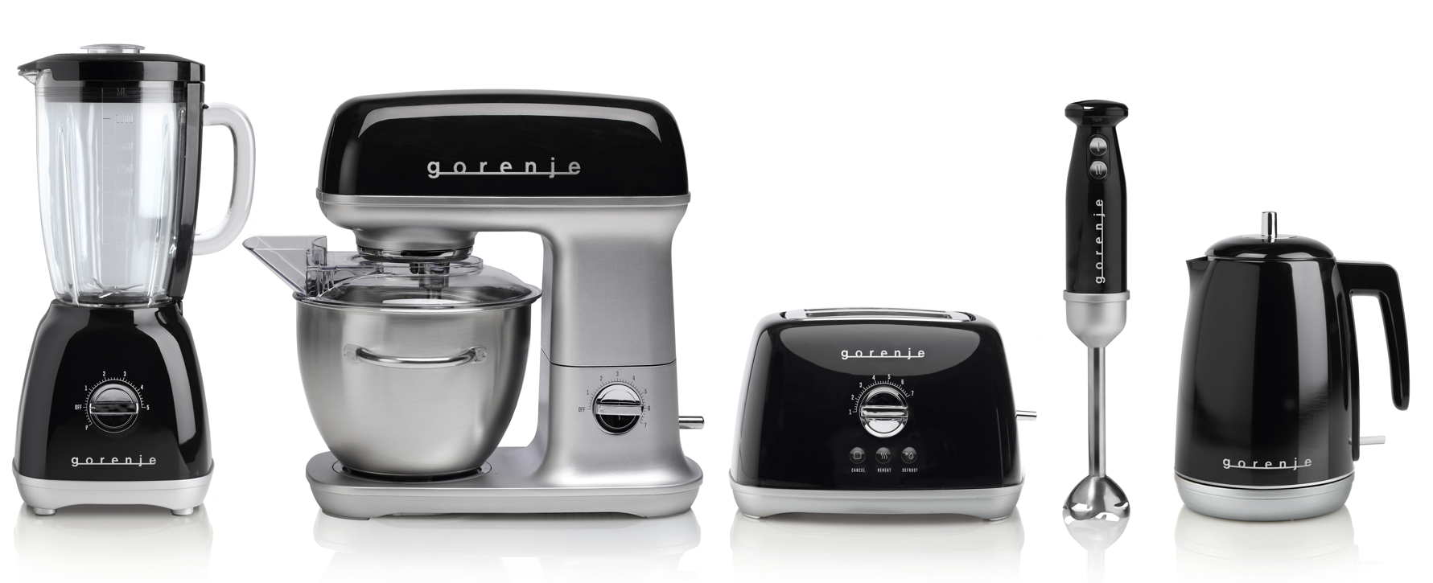

Photos: https://we.tl/t-Gxan8JcG7m

